

**Term Work**

**On**

**Data Base Management Systems**

**(TCS 503)**

**Submitted to: Submitted by:**

Mr. Samir Rana Prahlad Singh Aswal  
Assistant Professor University Roll. No.: 2018550  
GEHU, D. Dun Class Roll No./Section: 39/A

**DEPARTMENT OF COMPUTER SCIENCE AND ENGINEERING**

**GRAPHIC ERA HILL UNIVERSITY, DEHRADUN**

**DEPARTMENT OF CSE**

|  |
| --- |
| Photograph  Passport Size |

**STUDENT LAB REPORT SHEET**

**Name of Student ....................................................Mob.No......................................**

**Address Permanent.....................................................................................................**

**Father’s Name ......................................Occupation ...........…… Mob. No…………………..**

**Mother’s Name .................................. Occupation ....................Mob.No....................**

**Section ............ Branch ............ Semester ............ Class Roll No ............Grade A BC**

**Local Address ................................... Email ............................................ Marks 5 31**

|  |  |  |  |  |  |  |  |  |
| --- | --- | --- | --- | --- | --- | --- | --- | --- |
| **S.No.** | **Practical** | **D.O.P.** | **Date of Submission** | **Grade (Viva)** | **Grade (Report File)** | **Total Marks (out of 10)** | **Student’s Signature** | **Teacher’s Signature** |
| **1** |  |  |  |  |  |  |  |  |
| **2** |  |  |  |  |  |  |  |  |
| **3** |  |  |  |  |  |  |  |  |
| **4** |  |  |  |  |  |  |  |  |
| **5** |  |  |  |  |  |  |  |  |
| **6** |  |  |  |  |  |  |  |  |
| **7** |  |  |  |  |  |  |  |  |
| **8** |  |  |  |  |  |  |  |  |
| **9** |  |  |  |  |  |  |  |  |
| **10** |  |  |  |  |  |  |  |  |

|  |  |  |  |  |  |  |  |  |
| --- | --- | --- | --- | --- | --- | --- | --- | --- |
| **S.No.** | **Practical** | **D.O.P.** | **Date of Submission** | **Grade (Viva)** | **Grade (Report File)** | **Total Marks (out of 10)** | **Student’s Signature** | **Teacher’s Signature** |
| **11** |  |  |  |  |  |  |  |  |
| **12** |  |  |  |  |  |  |  |  |
| **13** |  |  |  |  |  |  |  |  |
| **14** |  |  |  |  |  |  |  |  |
| **15** |  |  |  |  |  |  |  |  |
| **16** |  |  |  |  |  |  |  |  |
| **17** |  |  |  |  |  |  |  |  |
| **18** |  |  |  |  |  |  |  |  |
| **19** |  |  |  |  |  |  |  |  |
| **20** |  |  |  |  |  |  |  |  |

Total No of Practical allotted ……………………...

Total No of Practical completed ……………………

Percentage Attendance of Practical ………………...

**Output**

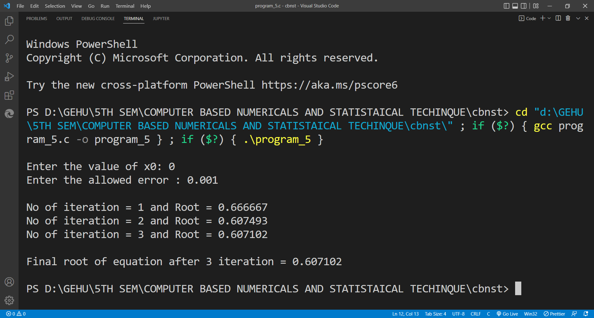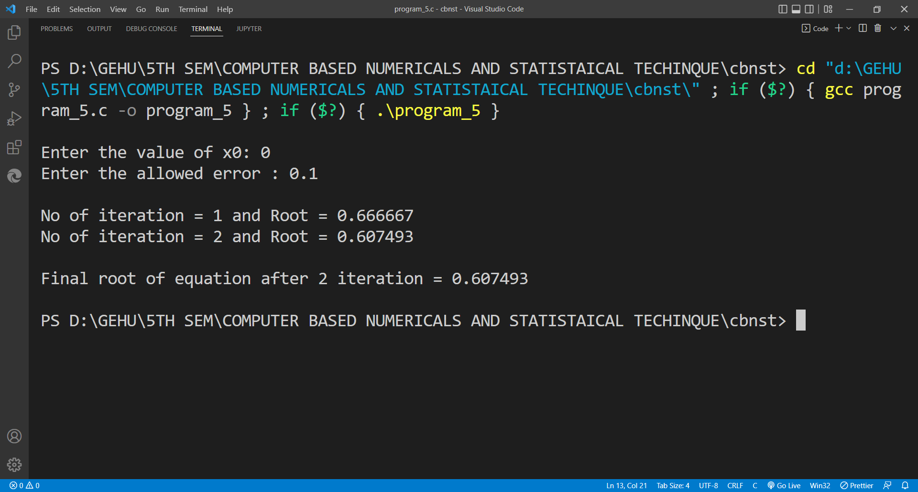**Equation:** - (3 * x) - cos(x) - 1

**Output**

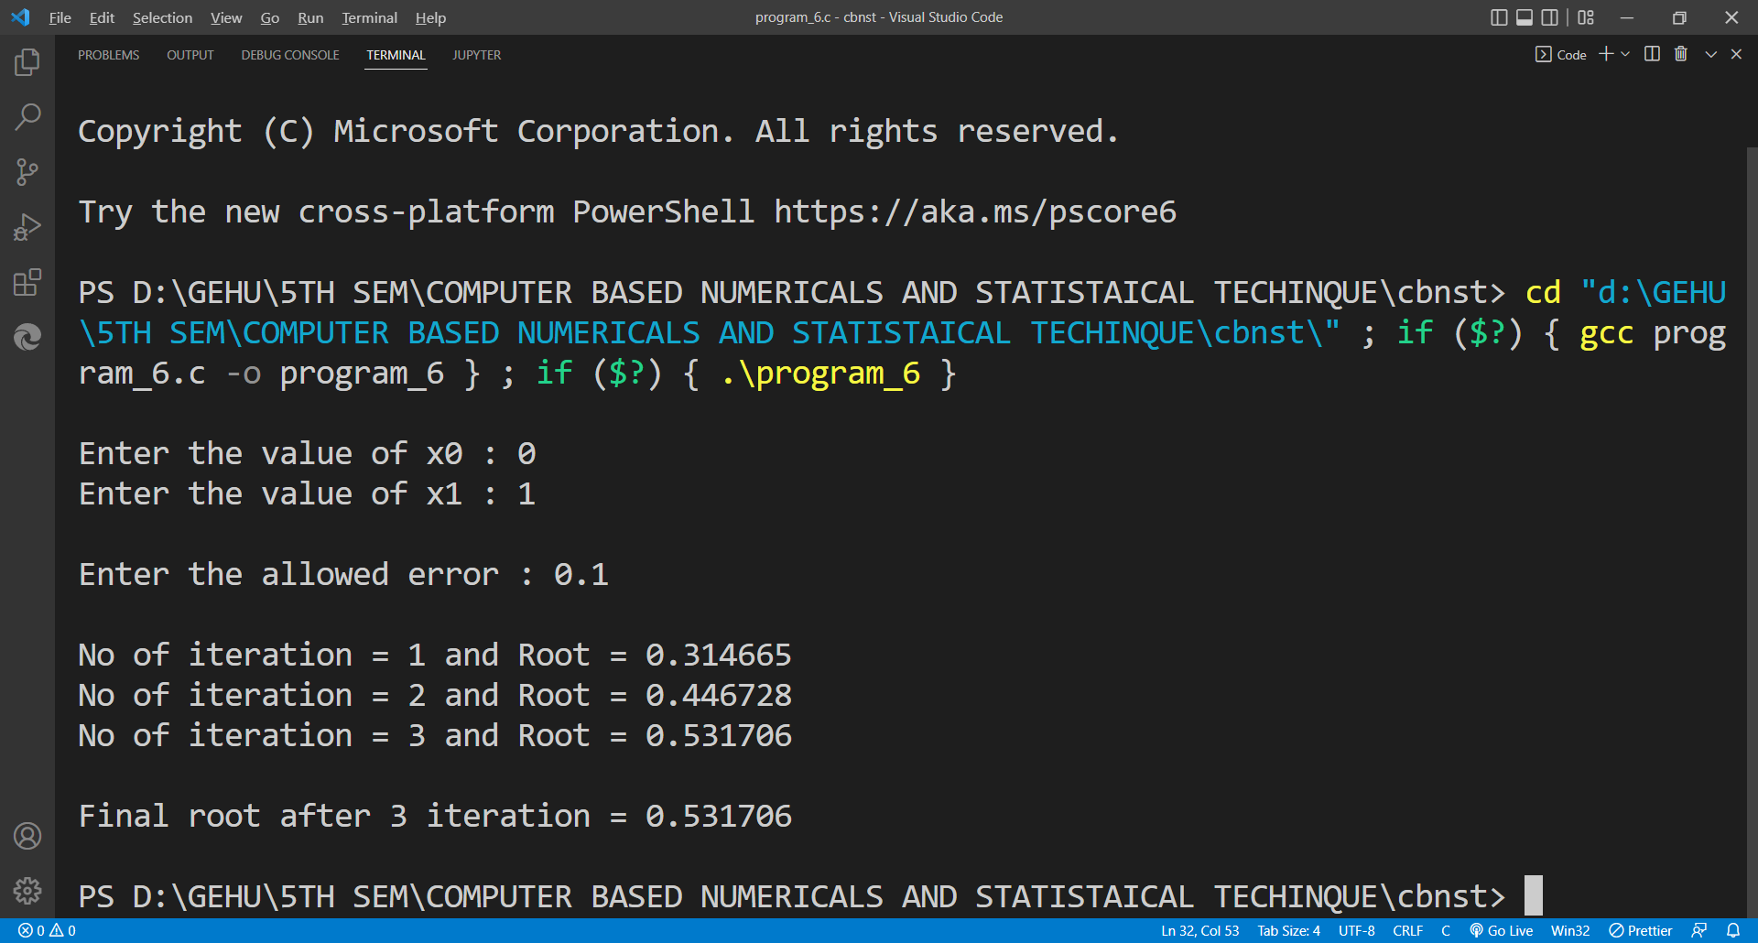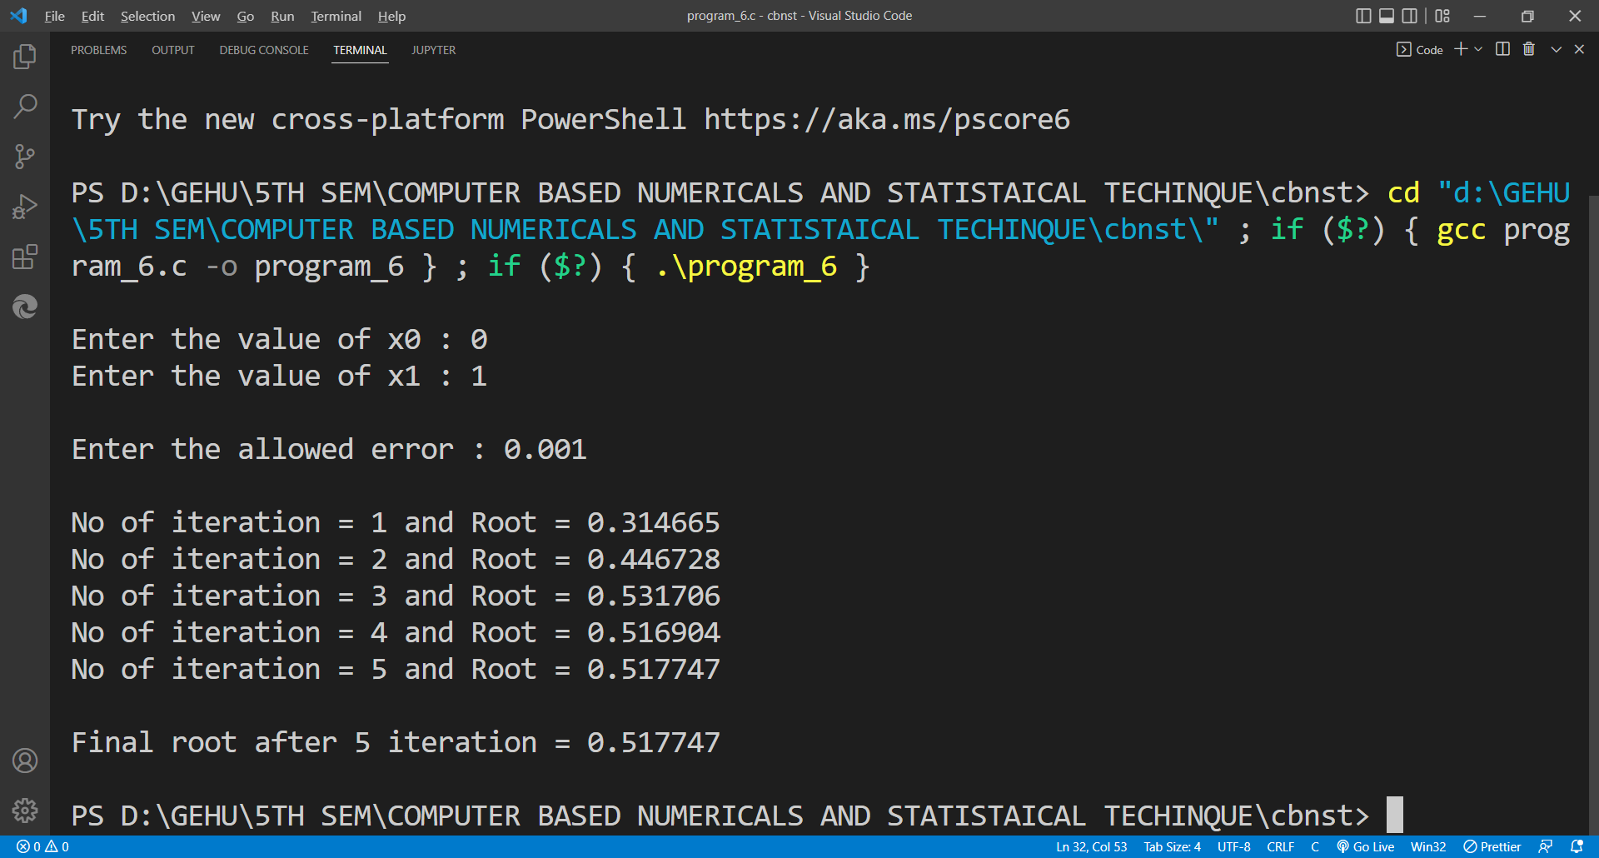**Equation:** - (x * exp(x)) - cos(x)

**OUTPUT**

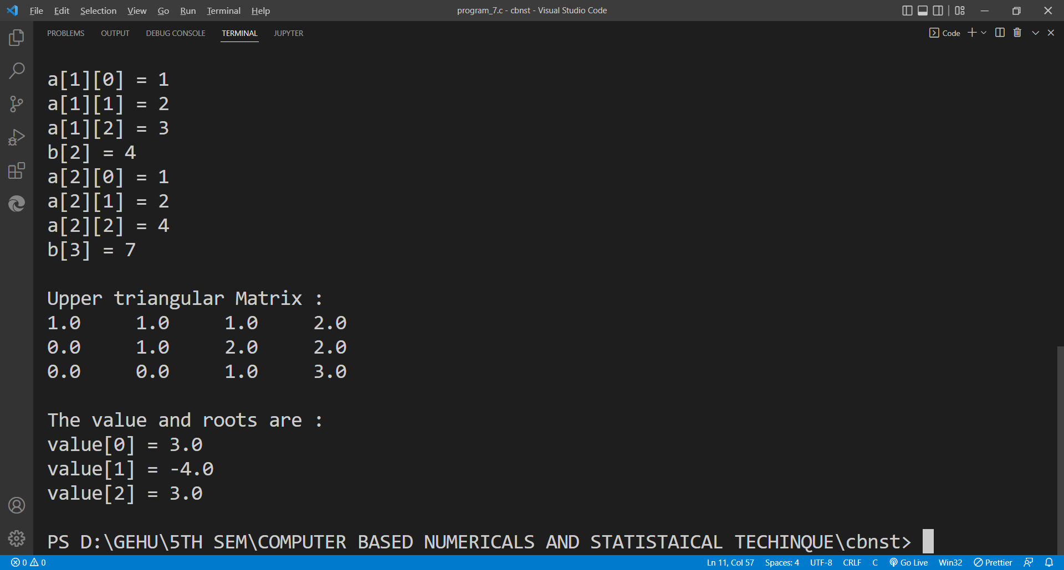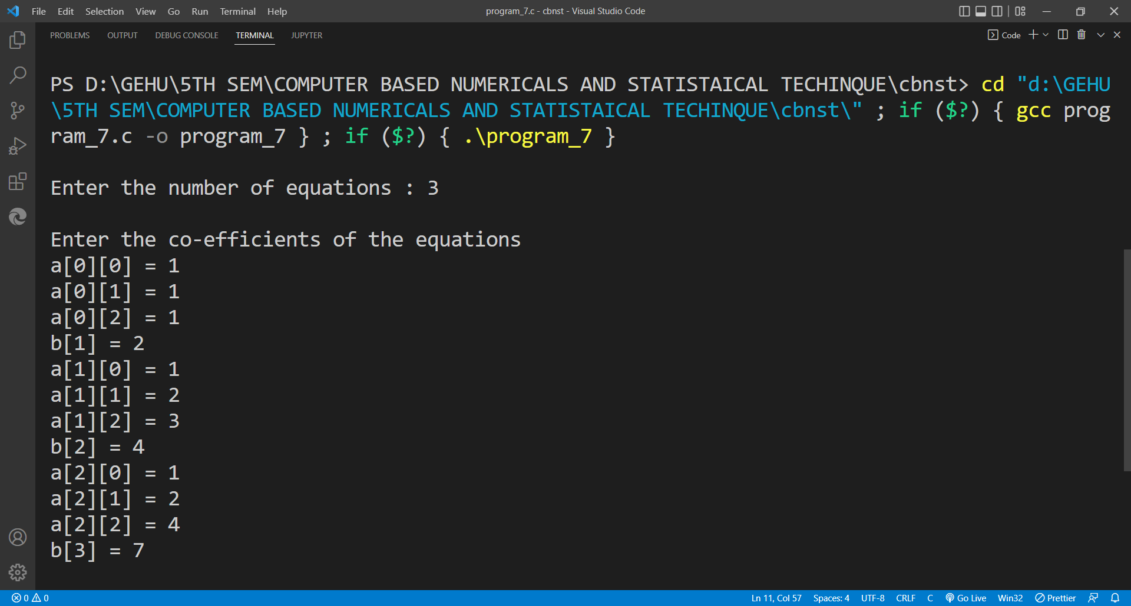

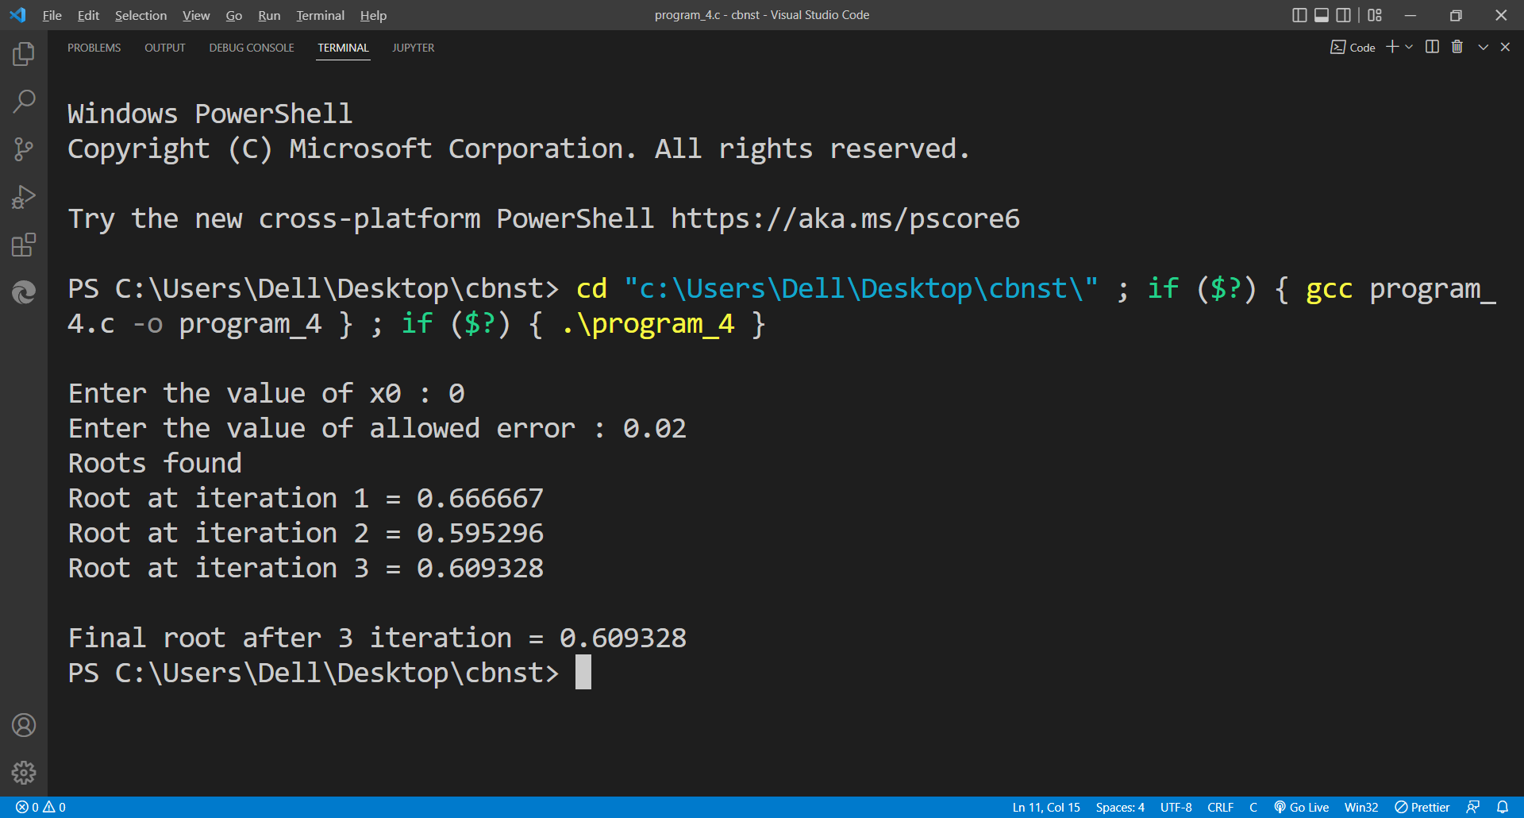**OUTPUT**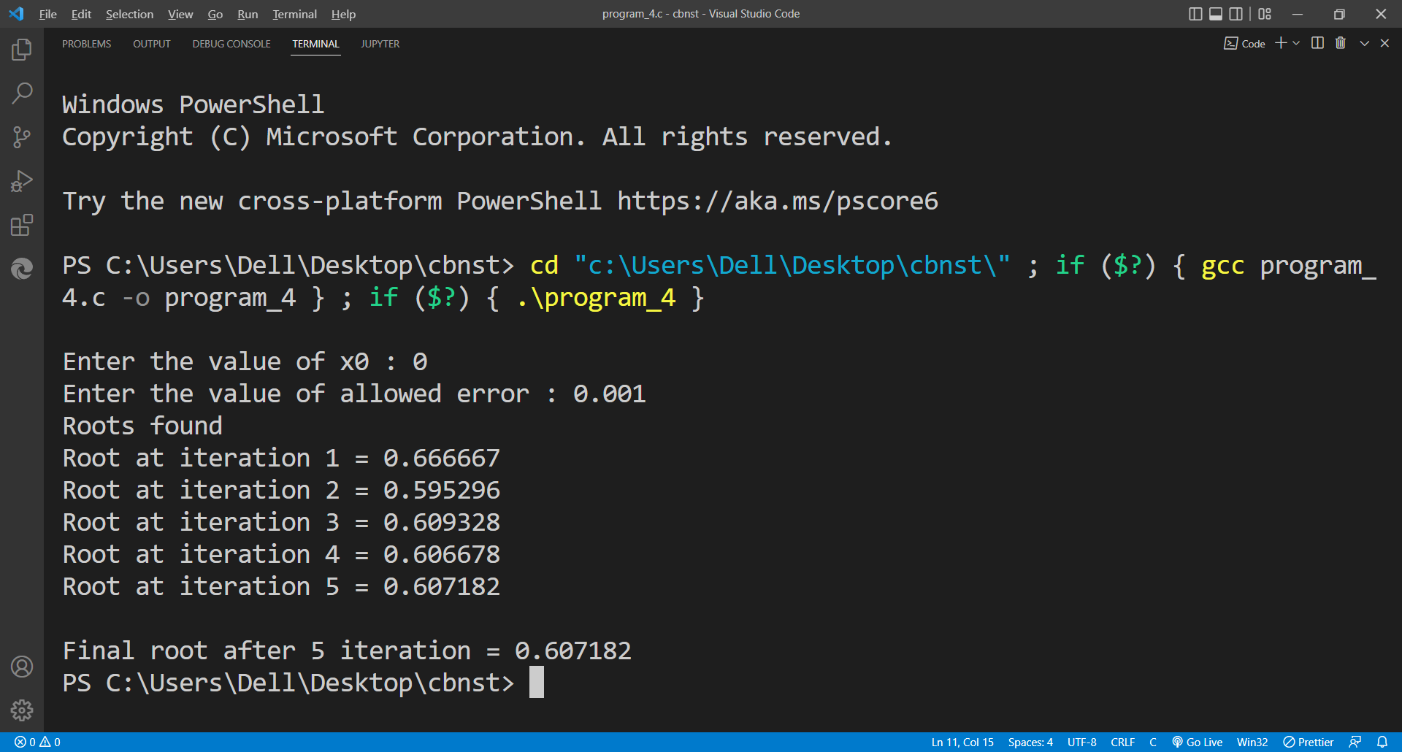

**Equation:-** cos(x) - (3 * x) + 1